**FRIEND AFFINITY FINDER**

**Team Name** - Missing Semicolon

**Team Member** - Shri Saran Raj N

**UNIQUENESS/NOVELTY:**

* Automated categorization of users based on their value points with efficient machine learning algorithm stands as the base novelty of the application.
* As an added benefit, every time when a new data is found, the model trains itself automatically to make predictions of the model more accurate.
* Collection of user data with his consent from various resources such as twitter, reddit stands as huge data store for analysing the natural affinity between people.

**TARGET PERSONAS**: Social Media Users

**IMPACT IN BUSINESS:**

* Researching about person’s attributes to understand more about the commonalities that we share with our friends in terms of their behavior, choices, likes and dislikes and so much more is one of the biggest challenges.
* Automation of this particular action through an intelligent process for every kind of user who often uses social media increases the usage of the application which proportionally increases the business value.
* Time and work being the most important things saved through this process will increase user’s interest towards this application.
* Also on usage of information from various sources increases accuracy of prediction of user’s affinity which results in customer satisfaction.

**SCOPE OF WORK TO BE IMPLEMENTED:**

Description:

* Adding additional resources to fetch data and increase accuracy.
* Increasing efficiency by increasing level of personality match to friends of friends as well.

Modules:

Instagram Module:

* Adding instagram login
* Fetching user preferences,friends preferences

Friends-of-Friends Module:

* Getting friends of friends by requesting the friend.
* Accessing information and calculating affinity.

**ARCHITECTURAL FLOW:**

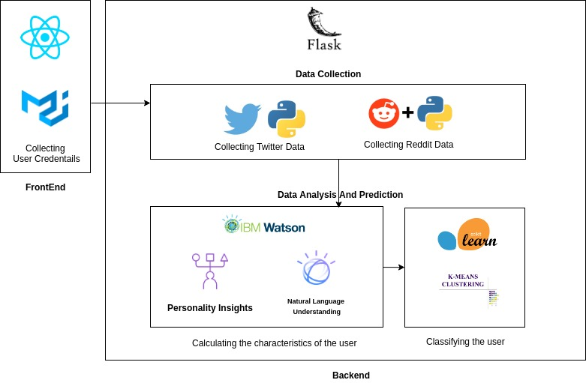

**BASIC WORKFLOW:**

First of all the user has to login by using his twitter username.If the user has an account in reddit then he can also enter those details because it will be more helpful to identify the user preferences.After that the tweets of the user are collected and the personality insights and sentiment analysis are collected from IBM Watson.Now , these data will hit the machine learning model which predicts and classifies the user.Now we have to classify our friends and have to show the match percent.So when the user clicks the Find A Match button each and every friend data has been analyzed and the user is classified with a percentage score.

**ALGORITHM FOR CLASSIFICATION OF USERS :** KMeans Clustering